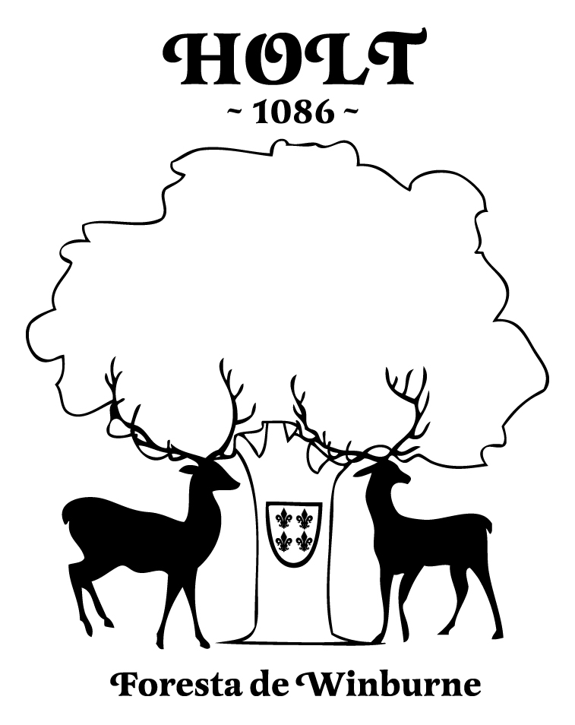
Holt Parish Council
Stone Cottage, Hinton Martell, Wimborne, Dorset. BH21 7HE
Clerk to the Council: Mrs Lisa Goodwin 01258 840935
E-Mail: clerk@holtparishcouncil.org.uk
www.holtparishcouncil.org.uk

VACANCY FOR PARISH COUNCILLOR

Please return to postal/email address above.

Name:

Address:

Tel:

Email:

Employment/Occupation:

How long have you lived in the area?

Please tell us about yourself, your interests and what skills you can bring to the Parish Council.

I confirm I meet the statutory requirements to be a member of a local council as specified in the 1972 Local Government Act s79 & s80.

Date: Signature:

