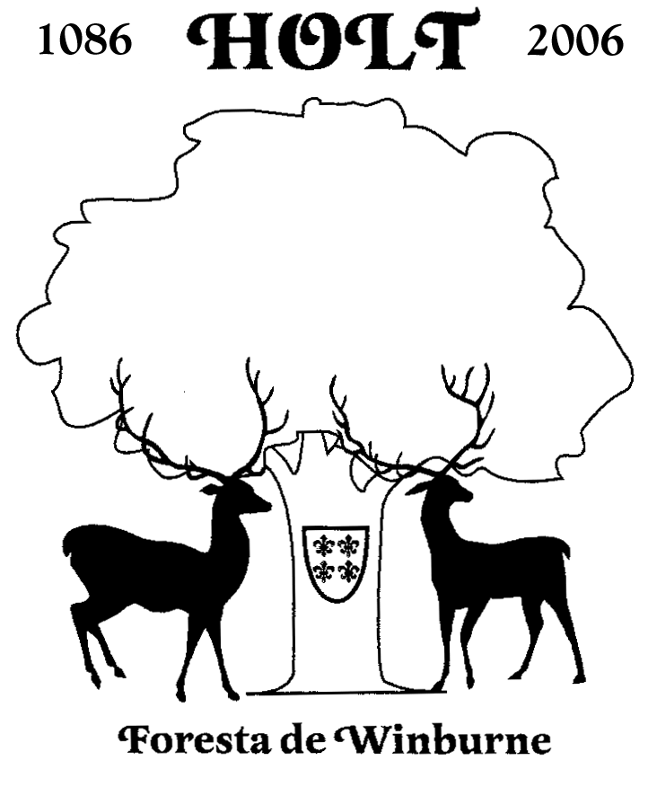
Holt Parish Council
Clerk to the Council: Mrs Lisa Goodwin 01258 840935
Stone Cottage, Hinton Martell, Wimborne, Dorset. BH21 7HE
E-Mail: clerk@holtparishcouncil.org.uk
www.holtparishcouncil.org.uk

Burial Ground Fees
effective 1st April 2023

Purchase of Plot Parishioner Non-Parishioner
Exclusive right of burial in perpetuity (optional)
Double depth graves are the same price – they can be purchased only at the time of burial and only if conditions are suitable

Earthen Grave £280.00 £1060.00
213.5cm x 91.5cm (7’x3’)

Grave for Cremated Remains
91.5cm x 91.5cm (3’x3’) £150.00 £590.00

Internment
For internment in a grave (regardless of whether exclusive rights of burial have been purchased.)

The body of a stillborn child or aged less
than one month. No fee £140.00

The body of a child aged from one month
to 16 years. No fee £210.00

The body of a person more than 16 years £170.00 £680.00

Cremated remains £120.00 £470.00

Memorials
To be placed at graves where exclusive rights of burial have been granted.
White marble is not permitted.

Headstones £120.00 £470.00
(must comply with cemetery regulations)

Stone Vase (with inscription) £60.00 £230.00

Inscription on existing headstone £60.00 £230.00

Parishioner means a person currently living in the boundary of Holt Parish or a person who has resided in the Parish and is considered by Holt Parish Council to be a Parishioner.

