Brief Details on Uddens House
Uddens House at Holt in Dorset was first built about 1747 for Nathaniel Gundry (c.1701-54), a judge in the Kings Bench division of the High Court. It was a relatively modest eight-bay house, set on the edge of a large area of heathland north of Wimborne Minster.
The last owner was Charlotte Elizabeth Greathed (c.1872-1952), It was not clear who her heirs were, but they evidently had no interest in the house, which was pulled down in 1955.
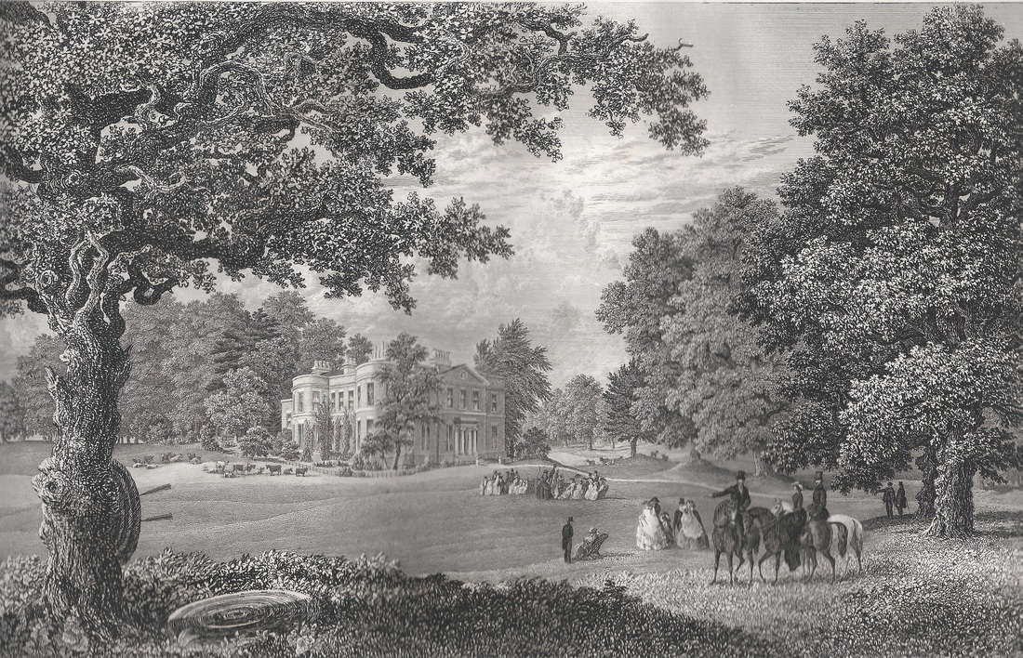
Engraving 1861
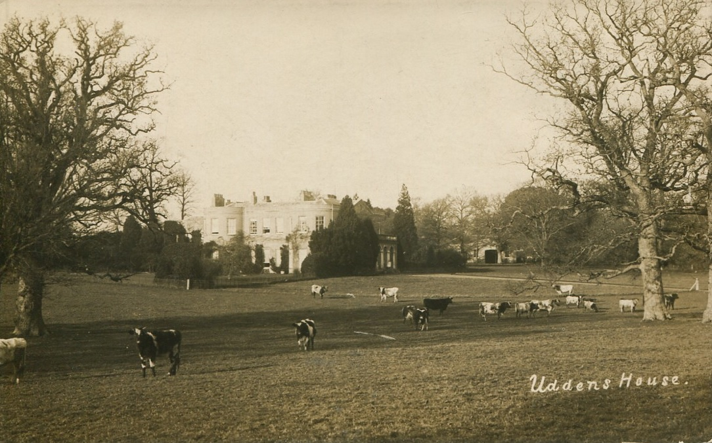
Early 1900s

